**SEEDS OF GOOD HOPE PRIMARY, NURSERY AND DAY CARE**

**END OF TERM III EXAMINATION 2023**

**TOP CLASS: (5 – 6 YEARS)**

**LEARNING AREA 5: LANGUAGE DEVELOPMENT II**

**My name is: ………………………………..………………………….**

**My School is: ……………………………..……….…………………..**

**I am in: ………………………………..…………………………………………..**

1. **Make words with these syllables.**

pi = _____________ le = ___________

bo = ____________ ba = ___________

ya = ____________ su = ___________

ve = ____________ ti = ____________

1. **Fill in the missing vowels.**

p ___ n b ___ lt f ___ sh

j ___ g b ___ n ___ n ___

h ___ n p ___ g h ___ nd

1. **Read these sentences**.

It is my goat.

I have two legs.

It is cold.

Ali has a big ball.

1. **Join and make words.**

do-g ___________ co-ld ___________

si-ck ___________ jo-b __________

de-sk __________ he-lp __________

1. **Listen and write.**

_______________________________________

_______________________________________

_______________________________________

_______________________________________

_______________________________________

1. **Name the pictures.**

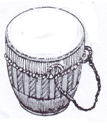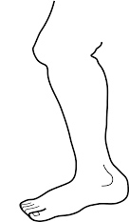

____________ ___________

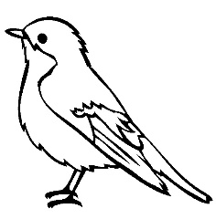

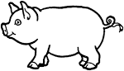 _____________ ___________

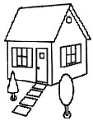

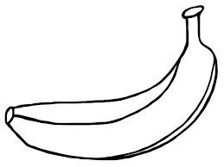

_____________ ____________

1. 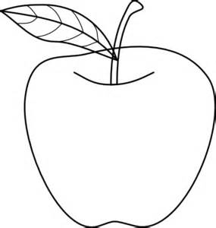**Write the first sound.**

_________



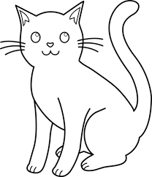 _________

_________



________

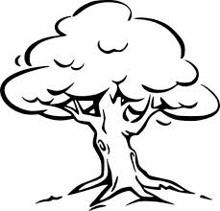

__________



_________

__________

***“Good Luck”***